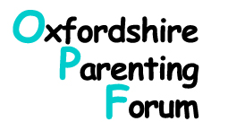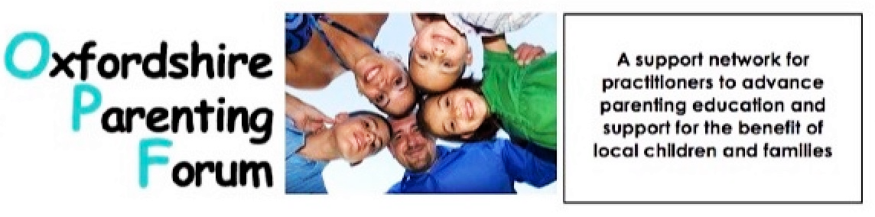
Registered Charity No.: 1080678 Patrons – Dr. John Coleman, Rosie Hill, Annette Mountford
Oxfordshireparentingforum.org email: OPFemail@gmail.com

Dear Colleagues,

We are pleased to announce that we have been meeting with members of the Oxfordshire County Council group responsible for the soon to be 'live' local Family Hubs in order to share our experience and expertise to support their planned parenting and home learning environment schedules. We have had our representatives contributing from the beginning of their 'task and finish group' meetings and as a result of the actions of our own trustee Sue Dowe, have widened their reach to include representatives from currently active Community run Family Centres. Our thanks to Sue and her colleagues for this very generous involvement!

Our 2 streams of limited funding are still available to any setting who are wanting to provide
1/a parenting puzzle workshop but only have one trained facilitator available; who would like to be able to run the group within the next 6 months.
If, by the end of this month, the funding has not been applied for, then we will provide 2 facilitators to the most deserving setting, if the need is there and if they have the facilities to accommodate a workshop.

2/some funding for 1:1 sessions for parenting support - this pot is limited but still has a small amount available so please don't hesitate to apply for either opportunity if you haven't yet done so.
Forms attached...

3/Don't forget the upcoming network meeting on Wednesday 4th March at 4.00 on Zoom Focusing on 'recruitment and retention in groups' if you are already part of the OPF nurturing network you will receive the joining link via that specific email...

OPF Trustees
(Networks Admin Team)

